Bert de Vries

# Short Biography (Summer 2012)

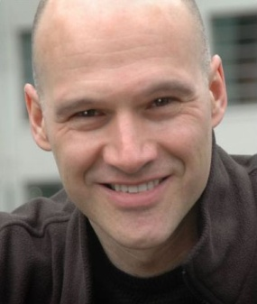Prof.dr. Bert de Vries grew up in Utrecht, the Netherlands. He received M.E. (1986) and Ph.D. (1991) degrees in Electrical Engineering from the Technical University Eindhoven and the University of Florida, respectively. From 1992 until 1999 he worked at Sarnoff Research Center in Princeton (NJ), where he contributed to research projects over a wide range of signal and image processing topics such as word spotting, financial market prediction and breast cancer detection from mammograms. Since April 1999 he has been employed in the hearing aids industry (currently at GN ReSound), both as a 'Principal Scientist' and also as a research manager. Since January 2012 he is also a 'part-time full Professor' in *Personalization of Medical Signal Processing Systems* in the Signal Processing Systems Group at the Technical University Eindhoven. At TU/e, he teaches the course *Adaptive Information Processing* to graduate electrical engineering students. He is an associate editor for the *IEEE Transactions on Neural Sciences and Rehabilitation Engineering*. His current research interests focus on developing Bayesian machine learning techniques for efficient tuning of a hearing aid algorithm to the specific preferences of the end user.